Poly-XTAL operations V9.04. Free MATLAB codebase to generate and analyse complex 2D poly-crystalline grain structures

Sunil Anandatheertha, M K Khan, Kristina Langer, Michael Fitzpatrick, G Narayana Naik, N G Subramania Udupa

**Author contributions**

|  |  |
| --- | --- |
| Sunil Anandatheertha | Conceptualization, Software development and maintenance, documentation and manuscript preparation |
| M K Khan | Conceptualization, Manuscript preparation, Responsible for funding. |
| Kristina Langer | Conceptualization, Responsible for funding, Manuscript preparation. |
| Michael Fitzpatrick | Conceptualization, Responsible for funding, Manuscript preparation. |
| G Narayana Naik (Masters supervisor) | Supervision (2013-2014), Manuscript preparation. |
| N G Subramania Udupa (Masters supervisor) | Supervision (2013-2014), Manuscript preparation. |
| K T Kashyap | Supervision (2010), Manuscript preparation.  [ktkashyap@yahoo.com](mailto:ktkashyap@yahoo.com), Responsible for funding |

**Development history:**

The 1st version to generate grain structures was written in 2010 in the department of mechanical engineering at PESIT, Bengaluru, India under the guidance of Dr. Kishore T Kashyap when employed as Junior Research Fellow. Available online since 2012 at:

1. <https://www.mathworks.com/matlabcentral/fileexchange/34784-monte-carlo-simulation-of-two-dimensional-grain-growth-code-version-no-1-basic?s_tid=prof_contriblnk>
2. <https://www.mathworks.com/matlabcentral/fileexchange/34985-monte-carlo-simulation-of-three-dimensional-grain-growth-code-version-no-1-basic?s_tid=prof_contriblnk>. <https://www.youtube.com/watch?v=FvlxVgXlbTI>).
3. 2nd to 8th version were written during 2013 – 2014 in the department of aerospace engineering at Indian Institute of Science for my master’s project under the guidance of Dr. G Narayana Naik (IISc) and Dr. N G Subramania Udupa (NCET).
4. Version 9 and above were written over the course of this PhD.

**Table of Contents**

1.1. Highlights 4

1.2. Abstract 4

Graphical abstract 4

1.3. Background and motivation 4

1.4. Functionalities 5

1.5. Capabilities 6

1.6. Applications 6

1.7. Available workflow paths for materials scientists 6

1.8. Theory, pseudo-code and implementation 7

1.8.1. Q-state Pott’s model 7

1.8.2. Boundary condition 8

1.9. Kernel weight functions 9

1.10. Functionalities and capabilities 11

1.10.1. Grain boundary segregation 11

1.10.2. Exporting “Poly-XTAL Operations” grain structure into MTEX 12

1.10.3. Temporal tracking of Hamiltonian and average grain size 13

1.10.4. Making 2nd phase particles 13

1.10.5. Making grain structures for CPFEM using Poly-XTAL Operations 13

1.10.6. Making grain structures for CPFEM using mtex2gmsh 14

1.10.7. Generate depth gradient texture using MTEX 14

1.11. References 15

1.12. Appendix-A: Gallery 15

1.13. Appendix-B: Structure 17

**Table of figures**

Figure 1: Numbering conventions used on the square lattice for theory and implementation 7

Figure 2: Illustration of boundary condition (a) rectangular grid (b) toroidal boundary condition with torsion $τη=0$ and $τζ=0$ (c) toroidal boundary condition with $τη=π2$ and $τζ=0$ 8

Figure 3: Boundary conditions (a) Peripheral type (b) Internal type 9

Figure 4: Example values of Kernel weight function parameters 10

Figure 5: Visualization of the Kernel weight matrix elements $Wij$ (a-i) and temporal slices of grain structure at Tsim. = 500 and 1000 evolved by using $Wij$ 11

Figure 6: (a, b) State wise partitioned number of grains at Tsim. = 500 and 1000 respectively (c & d) statistics of the number of grains at Tsim. = 500 and 1000 (e, f) grain size statistics at Tsim. = 500 and 1000 (g) temporal evolution of number of grains 12

Figure 7: Grain structure exchange between Poly-XTAL Operations 9.04 and MTEX 5.04 (a) Poly-XTAL Operations (b) Grain boundary mis-orientations calculated using MTEX (c) MTEX calculated grain shape distribution for the grain structure made in Poly-XTAL Operations 9.04 13

Figure 8: Types of 2nd phase particles which can be made: (a) Straight and thin nanotubes/needles, (b) Wavy and thin nanotubes, (c) Straight and thick nanotubes, (d) Wavy and thick nanotubes, (e) Nanotubes, Single lattice site particles and dense lattice site particle clusters and (f) Nanotubes, Single lattice site particles and single lattice site particle clusters 13

Figure 9: (a) Grain structure in Poly-XTAL Operations (b) Region inside the grain structure (c and d) Triangular and Quadrilateral mesh for the highlighted region in the grain structure, made using mtex2gmsh routine called from MTEX 5.04 14

Figure 10: Few example temporal slices of partitioned space having a maximum of 2 unique states. 16

Figure 11: Few example temporal slices of partitioned space having a maximum of 32 unique states 16

Figure 12: “Lattice” data structure 17

Figure 13: “MC_Param” data structure 18

Figure 14: “MC_Loop” data structure 18

Figure 15: “Vis_options” data structure 19

Figure 16: “PHASE” data structure 19

Figure 17: Data flow and structure in “Characterize_Grain_Structure_2D” 20

Figure 18: Data flow and structure in “Initialize__MCSolver_DATA” 21

Figure 19: Data flow and structure in “Minimize_Del_H_2D” 22

Figure 20: Behaviour of the total unit-normalized Hamiltonian $H$ as the system evolves temporally 23

## Highlights

* Free MATLAB codebase for researchers working on computational materials science, computational geology, dynamics of importance sampling Monte-Carlo schemes and graphenes.
* Make spatiotemporally gradient 2D grain structures and associate spatiotemporally gradient crystallographic texture to the grain structure
* Export ABAQUS input file for use in CPFEM
* Work with Ising model and Q-state Pott’s model simulation on square lattices
* Call MTEX libraries and mtex2gmsh

## Abstract

Computational materials science researchers who study multi-scale thermo-mechanical and texture behaviour of poly-crystalline materials need parametric and realistic geometric morphologies of the constituent phases reflected in grain structure. A virtual grain structure is often used by them as an input to further studies such as crystal plasticity based finite element analysis and other multi-physics studies. Though simplified and geometric grain structures have been used, there exists no tool to generate the spatial gradients in grain structure and texture as observed in the real world. This work presents a MATLAB package which users can use to create parametric temporally randomized spatially gradient grain structures and crystallographic texture. In addition to various in-built tools, ‘Poly-XTAL Operations’ can output in a format which can be opened in further 3rd party open source MATLAB based libraries such as MTEX to tend to their specific requirements. This package will also be a valuable tool for researchers working in importance sampling (discrete and continuous) Monte-Carlo techniques and geologists interested in modelling planet’s crust and soil behaviour. This paper briefs the basics for using ‘Poly-XTAL Operations V9.04’ and provide examples to understand the capabilities and enable easy usage. Functionalities, capabilities and possible applications are listed. Theory, structure, format and commands are explained. Links to repository, results gallery and detailed documentation are provided.

**Keywords**: (1) Poly-XTAL Operations (2) Grain structures (3) Ising model (4) Q-State Potts model

## Graphical abstract

## Background and motivation

Mathematicians, statistical mechanists and computational materials scientists are interested in studying the spatiotemporal evolutionary aspects of multi-phased partitioning of an n-dimensional space. We give four examples for this. The 1st example is from mathematics where researchers are interested in the chaotic partitioning of a n-D bounded spatial domain and its spatiotemporal evolution under some governing rules. The 2nd example is from statistical mechanics, the very well-known Ising model of the importance sampling Monte-Carlo techniques studying the spatiotemporal evolution of the kinetics and thermodynamics of the distribution of two phases in a lattice. Exact solutions have been developed for such simple models involving 2 states [1], but for more complex models like the Q-state Pott’s model, an exact model is impractical due to the vastness of the solution space. The 3rd example is from fundamental computational materials science where researchers are interested in grain growth [2], where the temporal evolution of the spatial and thermodynamical parameters of multi-phase grain structures [3,4] is studies. A part of this research also touches upon understanding the kinematic and kinetic behaviour of insoluble 2nd phase particles in grain structures [5] and how they interact with the grain boundaries. Some of these studies have tried to validate empirical models of grain structure geometry such as the Zener equation [6]. As the shape of the particles influence the Zener drag working against grain boundary evolution during grain growth [7], and that nature presents irregularly shaped particles, computer models which can consider such particle shape and their spatial distribution becomes very essential. The 4th example is from applied computational materials science where researchers need poly-crystalline grain structures to be used in techniques such as crystal plasticity based finite element analysis in order to study material’s phase-partitioned thermo-mechanical response and texture evolution under applied thermo-mechanical loads [8]. Though Voronoi tessellated geometries of grain structures have been used before in crystal plasticity-based simulations, they are simplifications and do not accurately represent the geometric irregularities presented by nature.

## Functionalities

1. Generate multi-phase 2D poly-crystalline grain structure. Ability to create:
   1. morphologically anisotropic grains
   2. spatially gradient grain morphologies in grain structure
2. Importance sampling Monte-Carlo on lattice to make realistic grains
   1. Ising model
   2. Q-state Potts model
3. Generate Voronoi equivalent of simulated and EBSD acquired grain structure
4. Consideration of following in grain growth simulation
   1. Artificial temperature gradients
   2. Spatiotemporal tracking of lattice energy
5. Grain identification and grain size statistics
6. Call MTEX libraries to:
   1. create spatial gradients in texture
   2. take advantage of its grain structure analysis routines native to MTEX
   3. carry out texture analysis
7. Export finite element mesh to ABAQUS input file for CPFEM studies using:
   1. in-built routines
   2. mtex2gmsh which uses gmsh

## Capabilities

1. Store >107 temporal slices of grain structures on a 10002 square lattice
2. Study grain boundary pinning from point particles, fully packed and sparse particle clusters (regular), thin and thick whisker reinforcements and nanotubes
3. Achieve spatial gradients in 2D Voronoi grain structure
4. Domain reduction by sparsing and sub-domain extraction
5. Open temporal slices of grain structures generated in Poly-Xtal operations in MTEX and take advantage of MTEX grain structure analysis tools
6. Track temporal evolution of grain structure statistics
7. Track temporal change in total and phase partitioned Hamiltonian
8. Generate tensile testing specimen with grain structure in the test

## Applications

1. Statistical mechanics. Study of Monte-Carlo algorithms and sampling techniques
2. FEM. Material scientists, engineers and geologists need realistic grain structures for further analysis such as crystal plasticity based finite element analysis.

## Available workflow paths for materials scientists

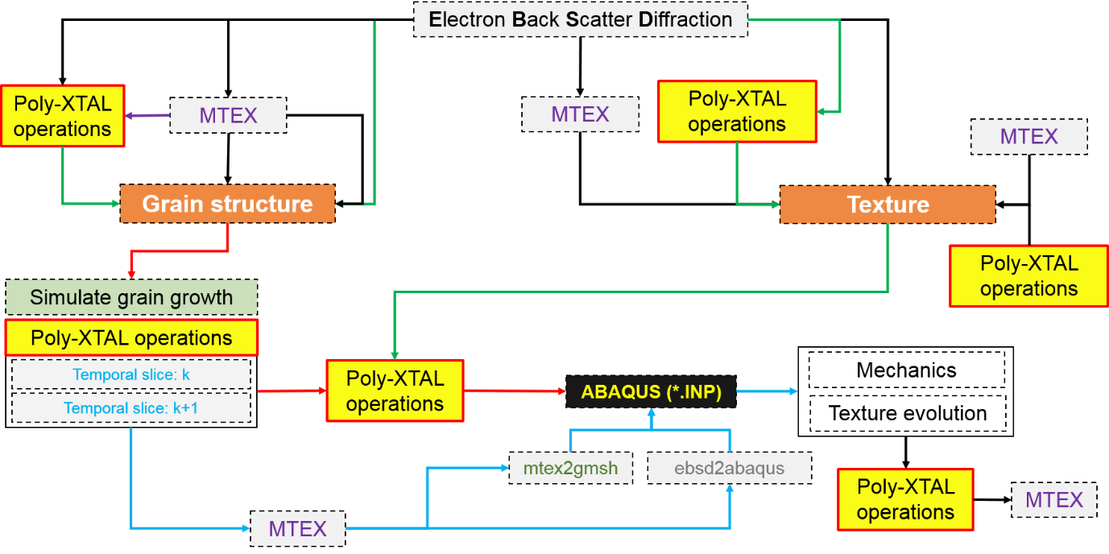

Figure 1:

## Theory, pseudo-code and implementation

### Q-state Pott’s model



Figure 1: Numbering conventions used on the square lattice for theory and implementation

The simulation can be carried out on any lattice. In this work, we consider a rectangular grid having an underlying square lattice shown in Figure 1(a). The grid has K*L lattice sites and is associated to ‘n’ state variables $T_{kl}^{n}\left(t\right)$ defining the temporal configuration of the domain, where ‘*t*’ represents simulation time. The state variables could be strongly or weakly coupled. In a weakly coupled set of state variables for example, either of $T_{kl}^{1}$ and $T_{mn}^{2}$ ($k,l,m,n∈\left(1:K, 1:L\right)$) is independent (say $T_{kl}^{1}$) and the other is dependent. This could be written as

$$T_{mn}^{2}=f\left(T_{kl}^{1}\right)$$

The partitioning of space evolves with the evolution of state variables. In this work, a single state variable $T_{kl}$ is considered. It is easy to incorporate a state variable into the solver code framework in Poly-XTAL operations. At every *n*th instance of the simulation time $t_{n}$, $T_{kl}\left(t_{n}\right)$ depends on $T_{ij}\left(t_{n-1}\right)$ where, $i,j=1,2,3$ form the set of 1st nearest neighbours. Temporal evolution of the value of $T_{kl}$ depends on the acceptable change brought about by $T_{kl}(t_{n})$ to a Hamiltonian ($H_{kl}$). This change is usually the reduction to $H_{kl}$ brought about at $t_{n}$ in comparison to $t_{n-1}$ as against that was brought about at $t_{n-1}$ by $t_{n-2}$. The objective is usually to reduce $H$ of the entire system. In a Q-state Pott’s model, there are Q number of possible unique $T_{kl}$ values for every lattice site $(k,l)$. In the modified Metropolis algorithm for the Q-state Pott’s model, $H_{kl}$ calculated as below [1]:

$$H_{ij}=-J\sum_{i=1}^{3}{\sum_{j=1}^{3}{δ_{T_{22 }T_{ij}}}}, \left(i,j\right)≠(2,2)$$

Where, $δ$ is the Kronecker delta and J is the isotropic boundary energy.

In this work, $H$ is modified as:

$$H=\sum_{k=1}^{K}{\sum_{l=1}^{L}{\left(-\sum_{i=1}^{3}{\sum_{j=1}^{3}{{\overline{W}}_{ij}δ_{T_{22 }T_{ij}}}}, \left(i,j\right)≠(2,2)\right)}}$$

Where, ${\overline{W}}_{ij}$ is the anisotropic boundary energy function defined over the domain grid.

The partition function becomes then $Z=\sum_{q=1}^{Q}{e^{\left(\frac{H}{k_{B}T}\right)}}$ where, T is the temperature and $K_{B}$ is the Boltzmann constant. The probability, therefore, of the system to be in $q^{th}$ state is $P\left(q\right)=\frac{e^{\left(\frac{H}{k_{B}T}\right)}}{Z}$. The probability with which the new state which does not reduce the Hamiltonian can still get accepted is the transition probability and is defined as $P_{tr}=\left\{\begin{matrix}\begin{matrix}e^{\frac{-ΔH_{ij}}{k_{B}T}} \\ 1\end{matrix} & \begin{matrix}ΔH_{ij}>0 \\ ΔH_{ij}≤0\end{matrix}\end{matrix}\right.$. By providing the capability to include a temperature field on the rectangular grid, spatially distributed transition probabilities can be used over the grid.

### Boundary condition



Figure 2: Illustration of boundary condition (a) rectangular grid (b) toroidal boundary condition with torsion $τ_{η}=0$ and $τ_{ζ}=0$ (c) toroidal boundary condition with $τ_{η}=\frac{π}{2}$ and $τ_{ζ}=0$

The present model uses self-contained uniquely mapped toroidal boundary condition on the rectangular grid. The present version uses zero-twist toroidal boundary condition shown in Figure *2*(b). The twisted toroid boundary condition shown in Figure *2*(b) can also be implemented and is described now. The parent rectangular domain is treated as a toroid shown in Figure *2*(b). Edges in the parent domain are $ς$ and corners are $μ$. Opposite edges interact ( $ς_{1}$ interacts with adjacent neighboursand $ς_{3}$; $ς_{2}$ interacts with adjacent neighbours and $ς_{4}$), adjacent opposite and diagonally opposite points interact ( $μ_{1}$ interact with adjacent neighbours, adjacent points $μ_{2}$ and $μ_{4}$ and diagonally opposite point $μ_{3}$. Similar interactions apply to $μ_{2}$, $μ_{3}$ and $μ_{4}$) in the calculation of Hamiltonian $H$. This is done internally in Poly-XTAL Operations 9.04 using an appended element matrix, “ea”. A twist can be introduced into the boundary conditions if needed. If these boundary conditions only define the interaction of grid points lying on the periphery of the domain, then they form the peripheral boundary condition in Poly-XTAL operations. This could be of twisted type. This is visualized in an example in Figure 3(a) for the sampled grid point 14.



Figure 3: Boundary conditions (a) Peripheral type (b) Internal type

It is not difficult to implement custom boundary conditions in “ea” by writing user defined mapping function/scheme to map the boundaries. A new type of uniquely mapped internal boundary condition $Γ$ operating on the entire domain $ω$ is proposed. It should be straight forward to implement. It is described now. Let $ω_{1}$, $ω_{2}$, …, $ω_{n}$, …, $ω_{N}$ be the set of sparsely intersecting sub-domains of $ω$. Let $ω_{ni }$ be the number of grid points belonging to $ω_{n}$, then $Γ$, operating over $ω$ maps $ω_{ni}$ to $ω_{nj}$ and $ω_{mk}$ where, $i≠j$ and $m≠n$. Two examples are given in Figure 3(b) for the sampled grid point 89 and 56. For the sampled member 89, interaction happens with 50, 53, 56, 92, 128, 125, 122 and 86. The twist in peripheral boundary condition applies only on the periphery and imposes no internal twists to the interaction and the interacting members are either horizontally or vertically or diagonally opposite. However, in the case of $Γ$, a twist makes a member say, 56 which interacts with non-horizontal, non-vertical and non-diagonally situated members and is shown in by dotted black lines with 53, 18, 21, 35, 71, 94, 91 and 77. A fundamental requirement of these self-contained boundary conditions (both peripheral and $Γ$ presented above) is that no member gets under-mapped or over-mapped.

## Kernel weight functions

Custom kernel weight functions can be incorporated easily into the solver. On a square grid of size $\left(K,L\right),$ say the sampled point is $\left(k.l\right).$ In the calculation of Hamiltonian $H_{kl}$, the sampled point is taken as $\left(i,j\right)=(2,2)$ having 8 first order nearest neighbours ((1,1) to (3,3), exluding (2,2)), where $i, j=1,2,3$. Here, a Kernel function is used to introduce anisotropic net non-zero moment into the sampling scheme. The kernel function used to demonstrate the capabilties in this paper is $W_{ij}=S_{ij}{\left(\frac{K_{ij}^{x}}{x_{ij}^{m_{ij}}}+\frac{K_{ij}^{y}}{y_{ij}^{n_{ij}}}\right)}^{Q_{ij}} @ a given i \& j$, where, the matrices $S_{ij}$ contains signs, $K_{ij}^{x}$, $K_{ij}^{y}$ and $Q_{ij}$ contain constants, and $x_{ij}^{m_{ij}}$ and $y_{ij}^{n_{ij}}$ contain spatial coordinates raised by constants. IN this expression, common subscripts do not imply summation. The calculated weights are unit normalized as ${\overline{W}}_{ij}=\frac{W_{ij}}{W_{ij}^{'}}$, where, $W_{ij}^{'}$ is the maximum of $\left|W_{ij}\right|$. For purposes of introducing flexibility, $W_{ij}^{'}$ could be non-homogeneosuly rescaled by **R** as ${\overline{W}}_{ij}=\frac{W_{ij}}{W_{ij}^{'}}*R= \frac{W_{ij}}{W_{ij}^{'}}*\left(L_{ij}+aR_{(3,3)}^{R}+bR_{\left(3,3\right)}^{z}+c\right)$, where, $L_{ij}$ is a scalin g matrix having real values, $a$, $b$ and $c$ are real constants and $R_{(3,3)}^{R}$ and $R_{\left(3,3\right)}^{z}$ are 3X3 matrices having random real and integer numbers respectively.



Figure 4: Example values of Kernel weight function parameters

In MATLAB, they are input in “**CODE NAME.m**” as below:

|  |  |  |
| --- | --- | --- |
| $$S_{ij}$$ | $$K_{ij}^{x}$$ | $$K_{ij}^{y}$$ |
| sign = [+1 +1 +1;  +1 +1 +1;  +1 +1 +1]; | xconst = [+1 +1 +1;  +1 +1 +1;  +1 +1 +1]; | yconst = [+1 +1 +1;  +1 +1 +1;  +1 +1 +1]; |
| $$m_{ij}$$ | $$n_{ij}$$ | $$Q_{ij}$$ |
| xpower = [1 1 1;  1 1 1;  1 1 1]; | ypower = [1 1 1;  1 1 1;  1 1 1]; | power = [-1 -1 -1;  -1 -1 -1;  -1 -1 -1]; |
| $$L_{ij}+aR_{(3,3)}^{R}+bR_{\left(3,3\right)}^{z}+c$$ | | |
| MultipleOfNorm = [+1 +1 +1;  +1 +1 +1;  +1 +1 +1] + 0.0*rand(3,3) -0.0 + 0.0*randi(2,3); | | |

It should be noted the sub-scripts *i* and *j* used above are not the ones used to represent lattice sites in the Hamiltonian calculation.



Figure 5: Visualization of the Kernel weight matrix elements ${\overline{W}}_{ij}$ (a-i) and temporal slices of grain structure at Tsim. = 500 and 1000 evolved by using ${\overline{W}}_{ij}$

Grain structure is simulated on a 100*100 rectangular grid with square grid and the 500th and 1000th temporal slices are shown in Figure *5*(i & k). Hamiltonian is calculated with using ${\overline{W}}_{ij}$ visualized in Figure *5*(a - i) considering 1st nearest neighbour interactions. Using different parameters for the calculation of ${\overline{W}}_{ij}$, different spatial partitioning can be generated with varying levels of symmetries. A few examples of the different parameters are provided in the appendix-C for a 32-state system. Users are urged to explore different generating parameters for ${\overline{W}}_{ij}$ and report any interesting spatial partitioning. The overall asymmetry in ${\overline{W}}_{ij}$ is represented in the visualization of ${\overline{∑W}}_{ij}=\frac{∑{\overline{W}}_{ij}}{\max\left(∑{\overline{W}}_{ij}\right)}$ in Figure *5*(e).

## Functionalities and capabilities for grain structure analysis in Poly-XTAL Operations

### Grain segregation

Grain structure is characterized using in-built tools. Poly-XTAL Operations can generate important statistics such as number distribution of number of grains (MORE CLARIFICATION NEEDED ON THE NUMBER OF GRAINS) and grain size. Figure 6. Grain segregation is done using frontal algorithm in the present version and is slow by nature for large systems. The code base allows the user to export the grain structure in a format using which grain segregation can be made much faster using in-built MTEX [9] algorithm [10].



Figure 6: (a, b) State wise partitioned number of grains at Tsim. = 500 and 1000 respectively (c & d) statistics of the number of grains at Tsim. = 500 and 1000 (e, f) grain size statistics at Tsim. = 500 and 1000 (g) temporal evolution of number of grains

### Temporal evolution of Hamiltonian and average grain size



Figure 20: Behaviour of the total unit-normalized Hamiltonian $H$ as the system evolves temporally

Figure 20 plots $H\left(t\right)$ for different number of states on different lattice sites for different volume fractions of single lattice site particles.

### Making 2nd phase particles



Figure 8: Types of 2nd phase particles which can be made: (a) Straight and thin nanotubes/needles, (b) Wavy and thin nanotubes, (c) Straight and thick nanotubes, (d) Wavy and thick nanotubes, (e) Nanotubes, Single lattice site particles and dense lattice site particle clusters and (f) Nanotubes, Single lattice site particles and single lattice site particle clusters

Types of 2nd phase particles that are included in Poly-XTAL Operations 9.04 are shown in example lattice grids in Figure *8*(a to f). The individual controlling parameters of such 2nd phase particles called Zener particles are provided in Figure 12 under the sub-structure “**zener**”. Detailed information about these parameters can be found in the technical manual.

### Making grain structures for CPFEM using Poly-XTAL Operations

## Some results

## Functionalities and capabilities enabled by 3rd party MATLAB libraries

### Analysing Poly-XTAL Operations generated grain structure in MTEX

Poly-XTAL operation” maps texture based crystalline orientations to each lattice site and constructs a CTF file commonly used by the EBSD community, which can then be easily imported into MTEX using the command “EBSDDATA= **loadEBSD(**'CTF_FILE_NAME.ctf**')**”. Once imported, all MTEX grain structure and texture analysis tools become available on all the temporal slices of grain structure formed using Poly-XTAL Operations.



Figure 7: Grain structure exchange between Poly-XTAL Operations 9.04 and MTEX 5.04 (a) Poly-XTAL Operations (b) Grain boundary mis-orientations calculated using MTEX (c) MTEX calculated grain shape distribution for the grain structure made in Poly-XTAL Operations 9.04

### Making grain structures for CPFEM using mtex2gmsh



Figure 9: (a) Grain structure in Poly-XTAL Operations (b) Region inside the grain structure (c and d) Triangular and Quadrilateral mesh for the highlighted region in the grain structure, made using mtex2gmsh routine called from MTEX 5.04

### Generate depth gradient texture using MTEX

## Data structure

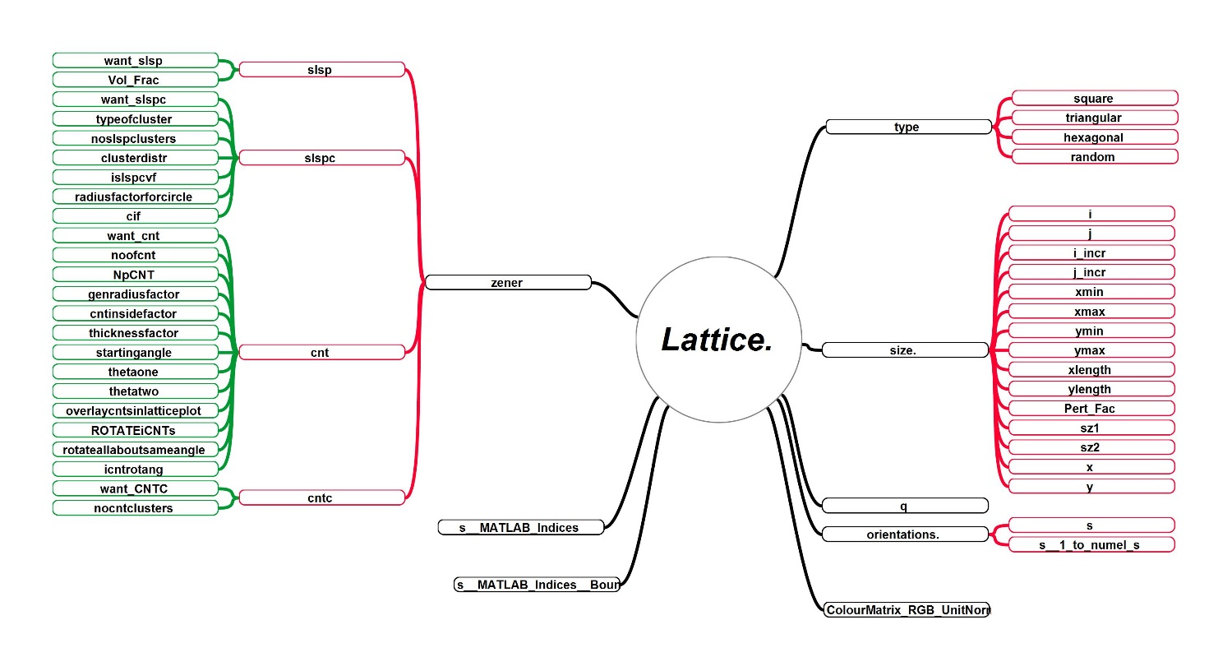

Figure 12: “Lattice” data structure

The structure **Lattice** is declared a global variable and is shown in the above figure stores user primary and secondary information about the lattice. Its level 1 sub-structures include type, size, q, orientations, Zener, s__MATLAB_Indices, S__MATLAB_Indices__Bounds and ColourMatrix_RGB_UnitNorm.

* “**type**” indicates the underlying lattice type. Its sub-structures are self-explanatory. The number of nearest neighbours to be considered in calculating $H$ is provided under the root structure “MC_Param”.
* “**size**” indicates the details of the grid. ‘i’ and ‘j’ are . WRITE HERE. ‘**x**’ and ‘**y**’ are the coordinates of the grid points and the ‘Pert_Fac’ controls the random perturbation introduced to ‘x’ and ‘y’.
* “**q**” is the total number of unique (states)/(configuration)/(crystal orientation) of the system.
* “**orientations**” is the grid of unique **q** value at each grid point. ‘**s**’ is the state matrix and ‘**s__1_to_numel_s**’ is the matrix having MATLAB’s indices of **s** (SEE IF THIS IS CORRECT).
* “**ColourMatrix_RGB_UnitNorm**” is a ‘**q** X 3’ vector storing normalized components of colour vectors r[0:255], g[0:255] and b[0:255]. Unit-normalization is done by 255. This is a random distribution with each colour associated to every unique value in “**orientations**”.
* “**s__MATLAB_Indices**” EXPLAIN HERE
* “**s_MATLAB_Indices__Bounds**” EXPLAIN HERE
* “**zener**” stores information of 2nd phase particles. Its substructures include “**slsp**”, “**slspc**”, “**cnt**” and “**cntc**”. They stand for “**s**ingle **l**attice **s**ite **p**articles”, “**s**ingle **l**attice **s**ite **p**article **c**lusters”, “**c**arbon **n**anotube **t**ype particles” and “**c**arbon **n**anotube **t**ype particle **c**lusters” respectively.

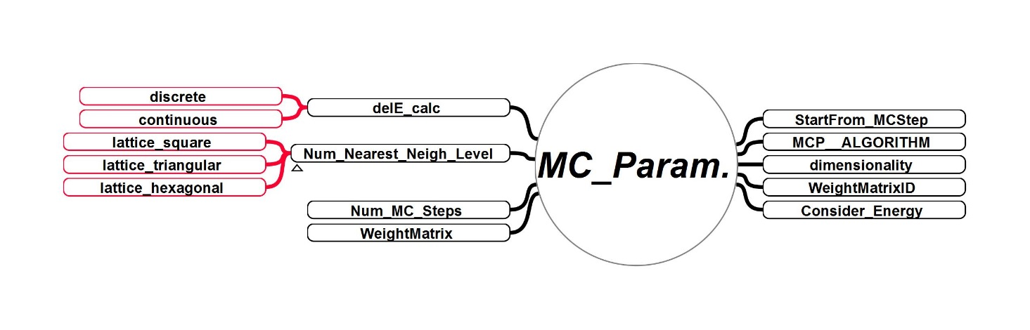

Figure 13: “MC_Param” data structure

The structure **MC_Param** is declared a global variable and is shown in the above figure. It stores user input information about the Monte-Carlo technique. Its level 1 and level 2 sub-structures are shown. Discrete and continuous sampling can be carried out and these are included in delE_calc. Square, triangular and hexagonal lattice can be chosen over the underlying square, triangular and hexagonal grid respectively. The number of Monte-Carlo steps over the entire domain is entered in “Num_MC_Steps”. The nth step to continue an ended simulation is entered in “StartFrom_MCStep”. Algorithm to be used is entered in “MCP_ALPGORITHM”. The number of dimensions of the domain is entered in “dimensionality”. The “WeightMatrixID” contains ID of the stored WeightMatrix WM applicable in KWF1A1, KWF1B1, KWF1B2, KWF1B3, KWF1C1, KWF1C2 and KWF1C3. Consider_Energy = 1 will save the Hamiltonian $H$, else it won’t be.

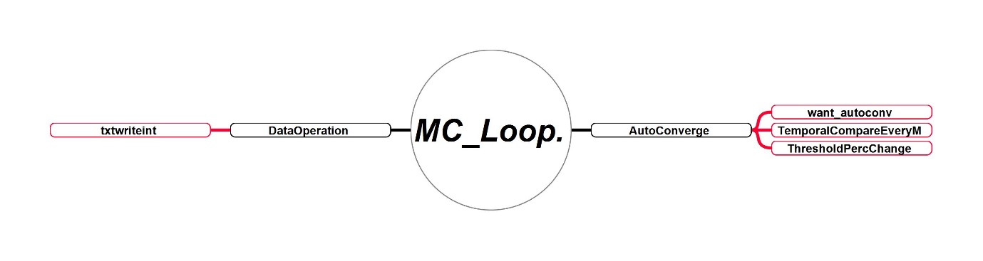

Figure 14: “MC_Loop” data structure

The structure “**MC_Loop**” is used to controls the evolutionary behaviour of energy calculation using the AutoConverge option while decides whether to end the energy calculations if $H(t)$ becomes asymptotic with $t$, which is decided by the Threshold Minimum Percentage Change specified in “ThresholdPercChange”. Sub-structures in “DataOperation” controls the data read and write operations.

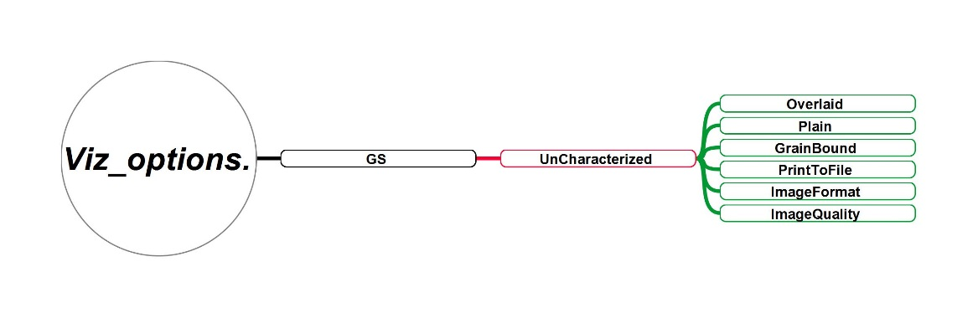

Figure 15: “Vis_options” data structure

The structure is designed to store all visualization options and parameters. The grain structure parameters “GS” currently contain only those parameters needed in the visualization of uncharacterized grain structure. Overlaid = 1 overlays the grain boundary on the coloured markers at the pixels, Plain = 1 plots lattice site orientations using coloured square markers, GrainBound = 1 plots the grain boundaries using black colour filled quares. PrintToFile controls whether the plot is exported to image file in the format specified in ImageFormat, with a quality specified by ImageQuality.

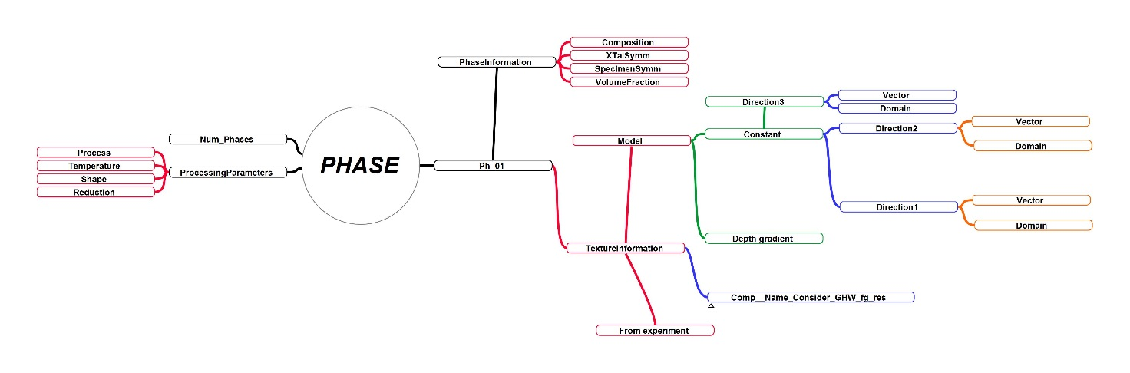

Figure 16: “PHASE” data structure

Each phase is stored under Ph_N, where N is the Nth phase. Input the number of phases to be used in the simulations in Num_Phases. Processingparameters is used to store the important parameters of processes such as rolling, extrusion, forging, etc. Ph_01 has two sub-structures as shown in the figure. The 1st is PhaseInformation which contain some basic information about the phases such as its compositional details, orientation parameters and volume fraction. The 2nd is the important TextureInformation used to generate crystallographic texture. depth gradient. Its sub-structure “Model”, “Comp__Name_Consider_GHW_fg_res” and “From_experiment” tell Poly-XTAL Operations, which texture model should be considered to make the synthetic texture; actual texture construction/re-construction parameters such as Gaussian Half Width; and parameters to import and use the real world texture respectively.

## Data Structure



Figure 17: Data flow and structure in “Characterize_Grain_Structure_2D”



Figure 18: Data flow and structure in “Initialize__MCSolver_DATA”



Figure 19: Data flow and structure in “Minimize_Del_H_2D”

## References

[1] R.J. Baxter, Exactly Solved Model in Statistical Mechanics, Academic press, Harcourt Brace Jovanovich, 1989.

[2] D. Weaire, S. Mcmurry, Some Fundamentals of Grain Growth, Solid State Phys. - Adv. Res. Appl. 50 (1996) 1–36. https://doi.org/10.1016/S0081-1947(08)60603-7.

[3] M.P. Anderson, D.J. Srolovitz, G.S. Grest, P.S. Sahni, Computer simulation of grain growth-I. Kinetics, Acta Metall. 32 (1984) 783–791. https://doi.org/10.1016/0001-6160(84)90151-2.

[4] M.P. Anderson, G.S. Grest, R.D. Doherty, K. Li, D.J. Srolovitz, Inhibition of grain growth by second phase particles: Three dimensional Monte Carlo computer simulations, Scr. Metall. 23 (1989) 753–758. https://doi.org/10.1016/0036-9748(89)90525-5.

[5] D.J. Srolovitz, M.P. Anderson, G.S. Grest, P.S. Sahni, Computer simulation of grain growth-III. Influence of a particle dispersion, Acta Metall. 32 (1984) 1429–1438. https://doi.org/10.1016/0001-6160(84)90089-0.

[6] P.A. Manohar, M. Ferry, T. Chandra, Five Decades of the Zener Equation, ISIJ Int. 38 (1998) 913–924. https://doi.org/10.2355/isijinternational.38.913.

[7] W.B. Li, K.E. Easterling, The influence of particle shape on zener drag, Acta Metall. Mater. 38 (1990) 1045–1052. https://doi.org/10.1016/0956-7151(90)90177-I.

[8] F. Roters, P. Eisenlohr, L. Hantcherli, D.D. Tjahjanto, T.R. Bieler, D. Raabe, Overview of constitutive laws, kinematics, homogenization and multiscale methods in crystal plasticity finite-element modeling: Theory, experiments, applications, Acta Mater. 58 (2010) 1152–1211. https://doi.org/10.1016/j.actamat.2009.10.058.

[9] F. Bachmann, R. Hielscher, H. Schaeben, Texture analysis with MTEX- Free and open source software toolbox, Solid State Phenom. 160 (2010) 63–68. https://doi.org/10.4028/www.scientific.net/SSP.160.63.

[10] F. Bachmann, R. Hielscher, H. Schaeben, Grain detection from 2d and 3d EBSD data-Specification of the MTEX algorithm, Ultramicroscopy. 111 (2011) 1720–1733. https://doi.org/10.1016/j.ultramic.2011.08.002.

## Appendix-A: Gallery



Figure 10: Few example temporal slices of partitioned space having a maximum of 2 unique states.



Figure 11: Few example temporal slices of partitioned space having a maximum of 32 unique states